**Project Design Phase-II**

**Data Flow Diagram & User Stories**

|  |  |
| --- | --- |
| Date | 31 January 2025 |
| Team ID | LTVIP2025TMID31922 |
| Project Name | Edu Tutor AI-Personalized Learning with Generative AI |
| Maximum Marks | 4 Marks |

**Data Flow Diagrams:**

A Data Flow Diagram (DFD) is a traditional visual representation of the information flows within a system. A neat and clear DFD can depict the right amount of the system requirement graphically. It shows how data enters and leaves the system, what changes the information, and where data is stored.

DFD of Edu Tutor AI

**Example: [(Simplified)](https://developer.ibm.com/patterns/visualize-unstructured-text/)**

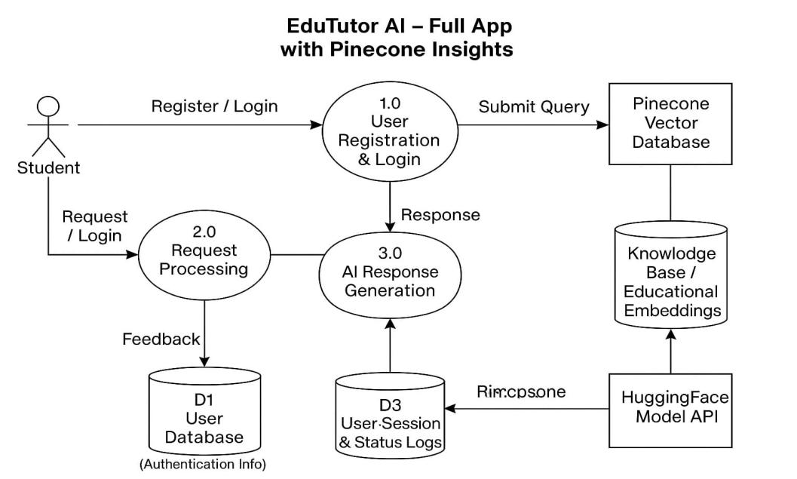

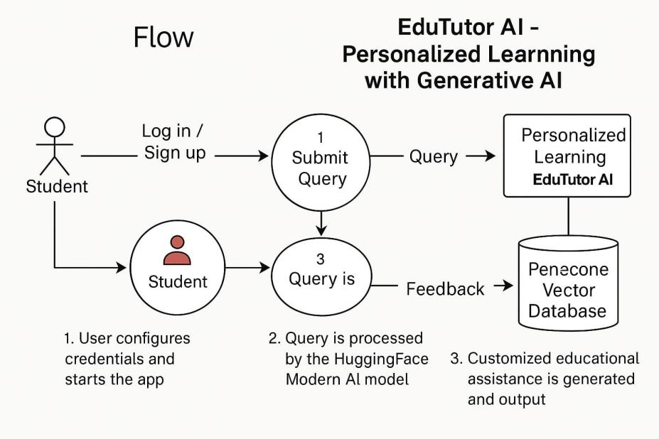

**User Stories**

| **User Type** | **Functional Requirement (Epic)** | **User Story Number** | **User Story / Task** | **Acceptance criteria** | **Priority** | **Release** |
| --- | --- | --- | --- | --- | --- | --- |
| Student (Mobile/Web) | Registration | USN-1 | As a student, I can register using email and password. | I can access the Edu Tutor AI dashboard after registration. | High | Sprint-1 |
|  | Social Login | USN-2 | As a student, I can sign up using Google. | I can register and access the dashboard using Google. | Medium | Sprint-2 |
|  | Login | USN-3 | As a student, I can log in using my registered credentials. | I can successfully access my account. | High | Sprint-1 |
|  | Dashboard | USN-4 | |  | | --- | |  |  |  | | --- | | As a student, I can view my enrolled courses and recommendations. | | Courses and personalized suggestions are visible on login. | High | Sprint-2 |
| Tutor(Web) | Profile Setup | USN-5 | As a tutor, I can create and update my teaching profile. | Profile is saved and shown to students. | Medium | Sprint-3 |
| Admin | User Management | USN-6 | As an admin, I can manage user roles and permissions. | I can activate/deactivate accounts. | High | Sprint-3 |
|  |  |  |  |  |  |  |